**Page 1 – The user can either enter login details or register**

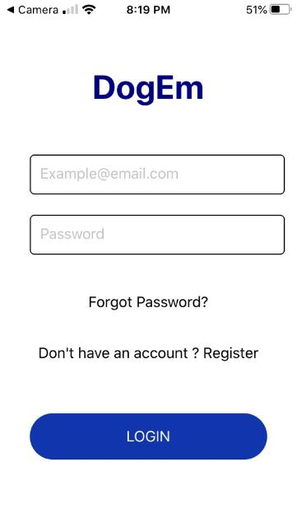

**Page 2 – Register: If the user selects “Register” on the initial page, they are directed here**

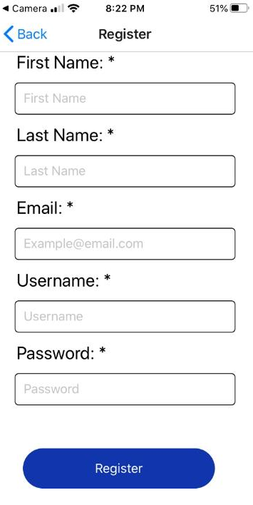

**Page 3 -- Upon selecting the “Register” button on the register page, an alert is generated:**

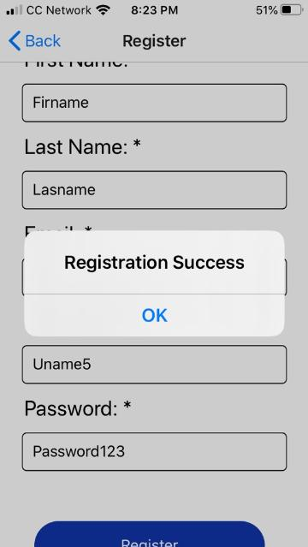

**Page 4 -- If the user selected “Log In” initially on the first page or they registered and now wish to sign in, this is what the filled in login page looks like**

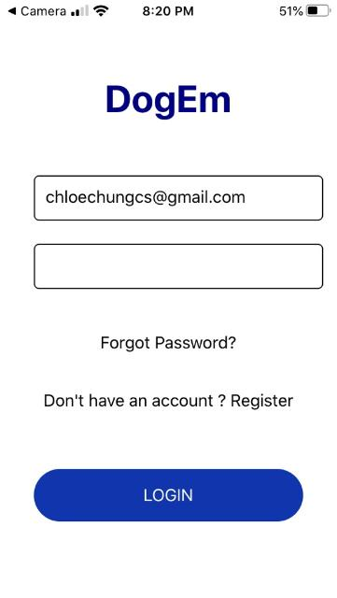

**Page 5 -- Homepage: This is where the user can view their contacts, add/edit contacts, or start dogging:**

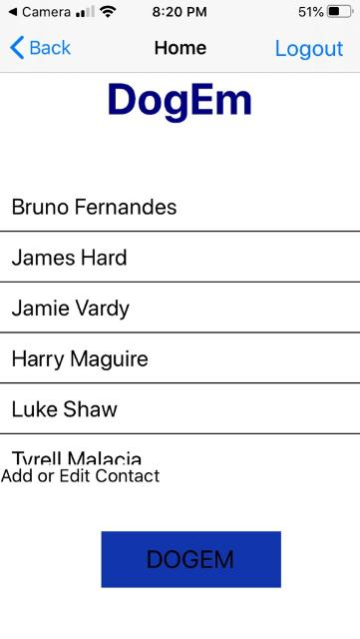

**Page 6 – Add/Edit Contacts page: If the user selects “Add or Edit Contact” on the homepage, they are directed here:**

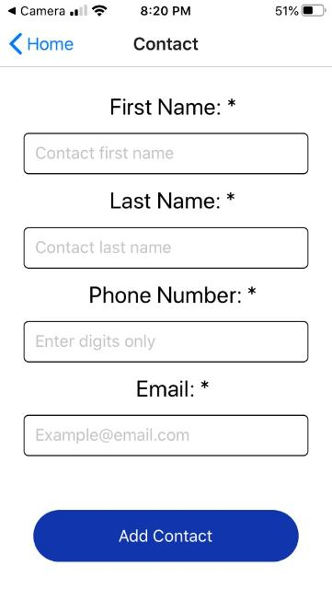

**Page 7 – After successfully adding a contact, the user receives an alert:**

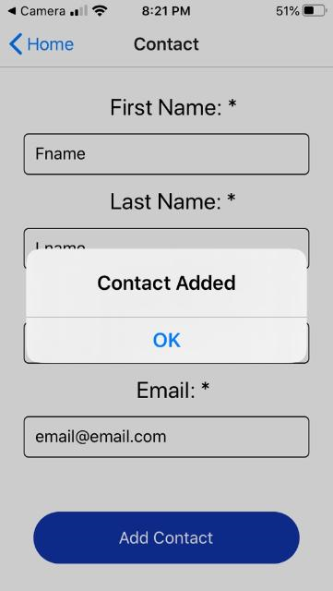

**Page 8 – DogEm Page: If the user selected “DOGEM” on their homepage, they are directed to the DogEm page**

